Hobbies club conducted various activities on 8th,9th September ( Gandhiji,s Birthday) association with Andhra Pradesh Smaraka Nidhi and Vasavya Mahila Mandali

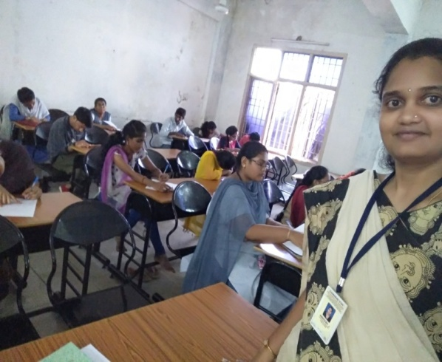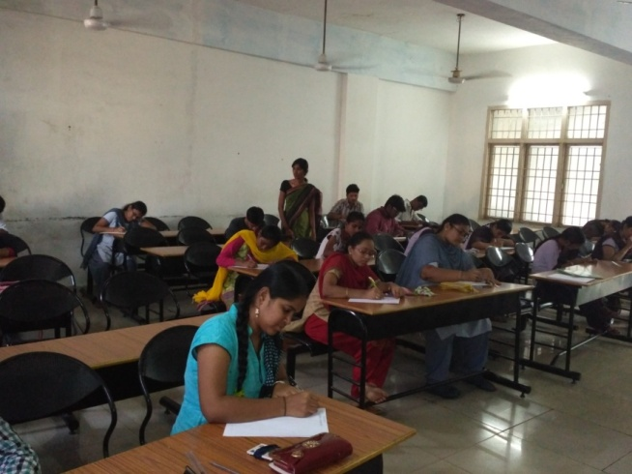

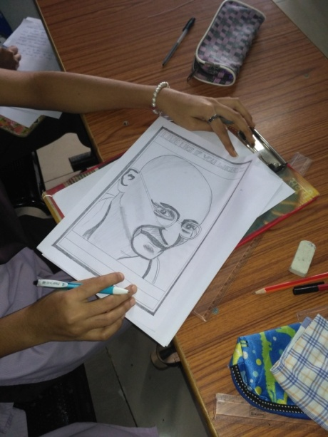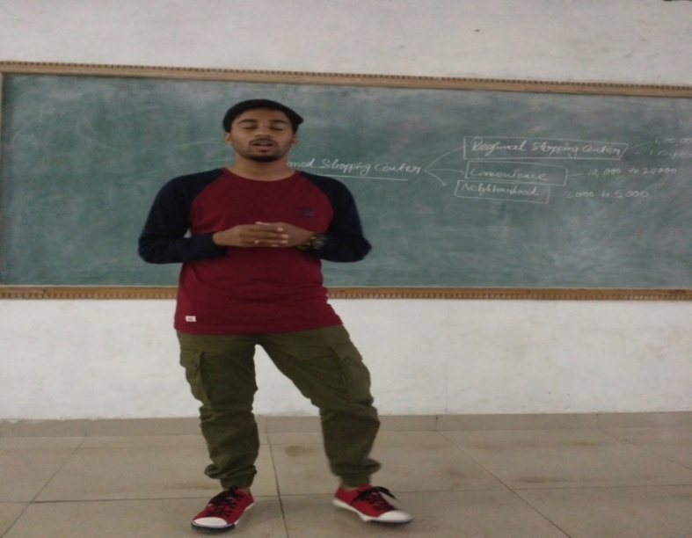

Hobbies Club conducted various activities like Essay writing, Drawing, Painting, Elocution, Singing to promote Gandhian,s Ideology in association with AP Smaraka Nidhi and Vasavya Mahila Mandali.
Hobbies Club Celebrated Independence day on 15th August 2018

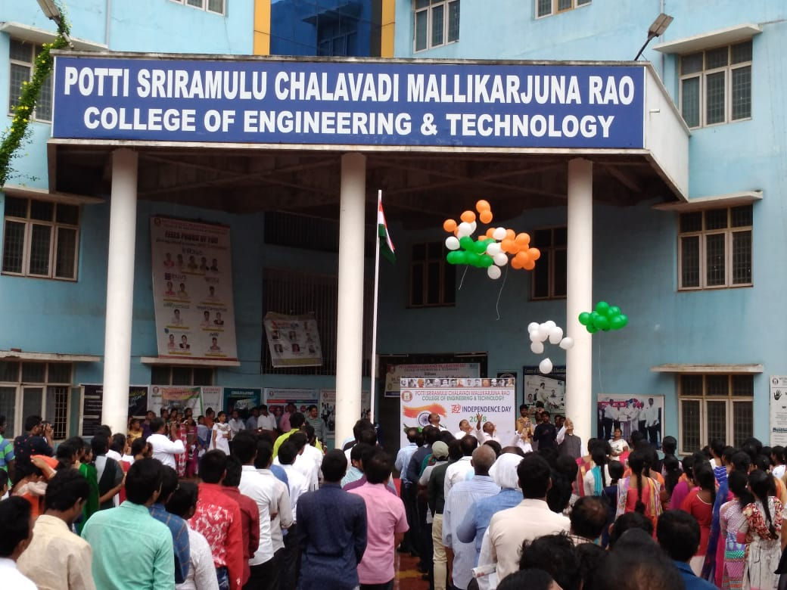
Independence Day is celebrated every year on 15th August. This was the day when India was freed from the British Rule. It is a national festival and has equal importance for every Indian regardless of religion, class, creed or race.
Different types of celebrations on Independence Day

- Flag hoisting
- As a symbol of freedom Released pigeons
- Singing(singing club) Patriatic song sung by singing club members
- Pics taken by photography club members

